Handout no. 2

|  |  |
| --- | --- |
| **Name** | Faizan , M Asad , AsadurRehman |
| **Reg. No** | 2019-EE-381, 383, 389 |
| **Marks/Grade** |  |

**EXPERIMENT # 2**

**Single Phase Current transformers**

**Objective:**

At the end of this lab session students will be able to

* Use De Lorenzo power system Protection kits.
* Implement “Current transformer” by using De Lorenzo power system Protection kits.
* Current Transformer operation in an electrical subsystem.

**Introduction:**

Utilities are responsible for the generation, transmission and distribution of electricity to customers. Part of this responsibility is ensuring a safe but yet reliable power supply to customers. For the purpose of safety and protecting the transmission and distribution network from faults, utilities worldwide have sophisticated protective equipment. Collectively, these are known as secondary equipment and include the current transformers (CT), potential transformer (PT) and protective relays.

**Apparatus:**

* 1DL 1017R Resistive Load
* 1DL 1055TT Experimentation Transformer
* 1DL 2108T10 CT LOAD
* 1DL 2109T21 Single Phase Current Transformer
* 2 DL 2109T5A Moving Iron Ammeter (5A)

**Current Transformers:**

The basic principle of the current transformer is the same as that of the power transformer. Like the power transformer, the current transformer also contains a primary and a secondary winding. Whenever an alternating current flow through the primary winding, alternating magnetic flux is produced, which then induces alternating current in the secondary winding. In the case of current transformers, the load impedance or “burden” is very small. Therefore, the current transformer operates under short circuit conditions. Also, the current in the secondary winding does not depend on load impedance but instead depends on the current flowing in the primary winding.

The current transformer basically consists of an iron core upon which primary and secondary windings are wound. The primary winding of the transformer is connected in series with the load and carries the actual current flowing to the load, while the secondary winding is connected to a measuring device or a relay. The number of secondary turns is proportional to the current flowing through the primary; i.e., the larger the magnitude of current flowing through the primary, more the number of secondary turns.

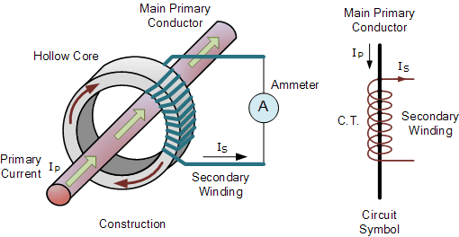

Figure 1 Working diagram of CT

The primary and secondary windings are galvanically separated and can be on a different potential level. The transformation ratio k of a current transformer is the number of secondary turns **Ns** to the number of primary turns **Np** and is equal to the primary current **Ip** over the secondary current **Is**.

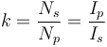

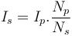

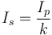

The ratio of primary current to the secondary current is known as the current transformation ratio of the CT. Usually the current transformation ratio of the CT is high. Normally the secondary ratings are of the order 5 A, 1 A, 0.1 A, whereas the primary ratings vary from 10 A to 3000 A or more.

The CT handles much less power. Rated burden can be defined as the product of current and voltage at the secondary side of the CT. It is measured in volt ampere (VA). Current Transformers (CT) are used for current metering and protection in high voltage network systems. They transform the high current on the high voltage side into low current (1 or 5 A) adequate to be processed in measuring and protection instruments (secondary equipment, such as relays and recorders). A current transformer also isolates the measuring instruments from the high voltage of the monitored circuit. Current transformers are commonly used for metering and protection in the electrical power industry.

***Circuit construction:***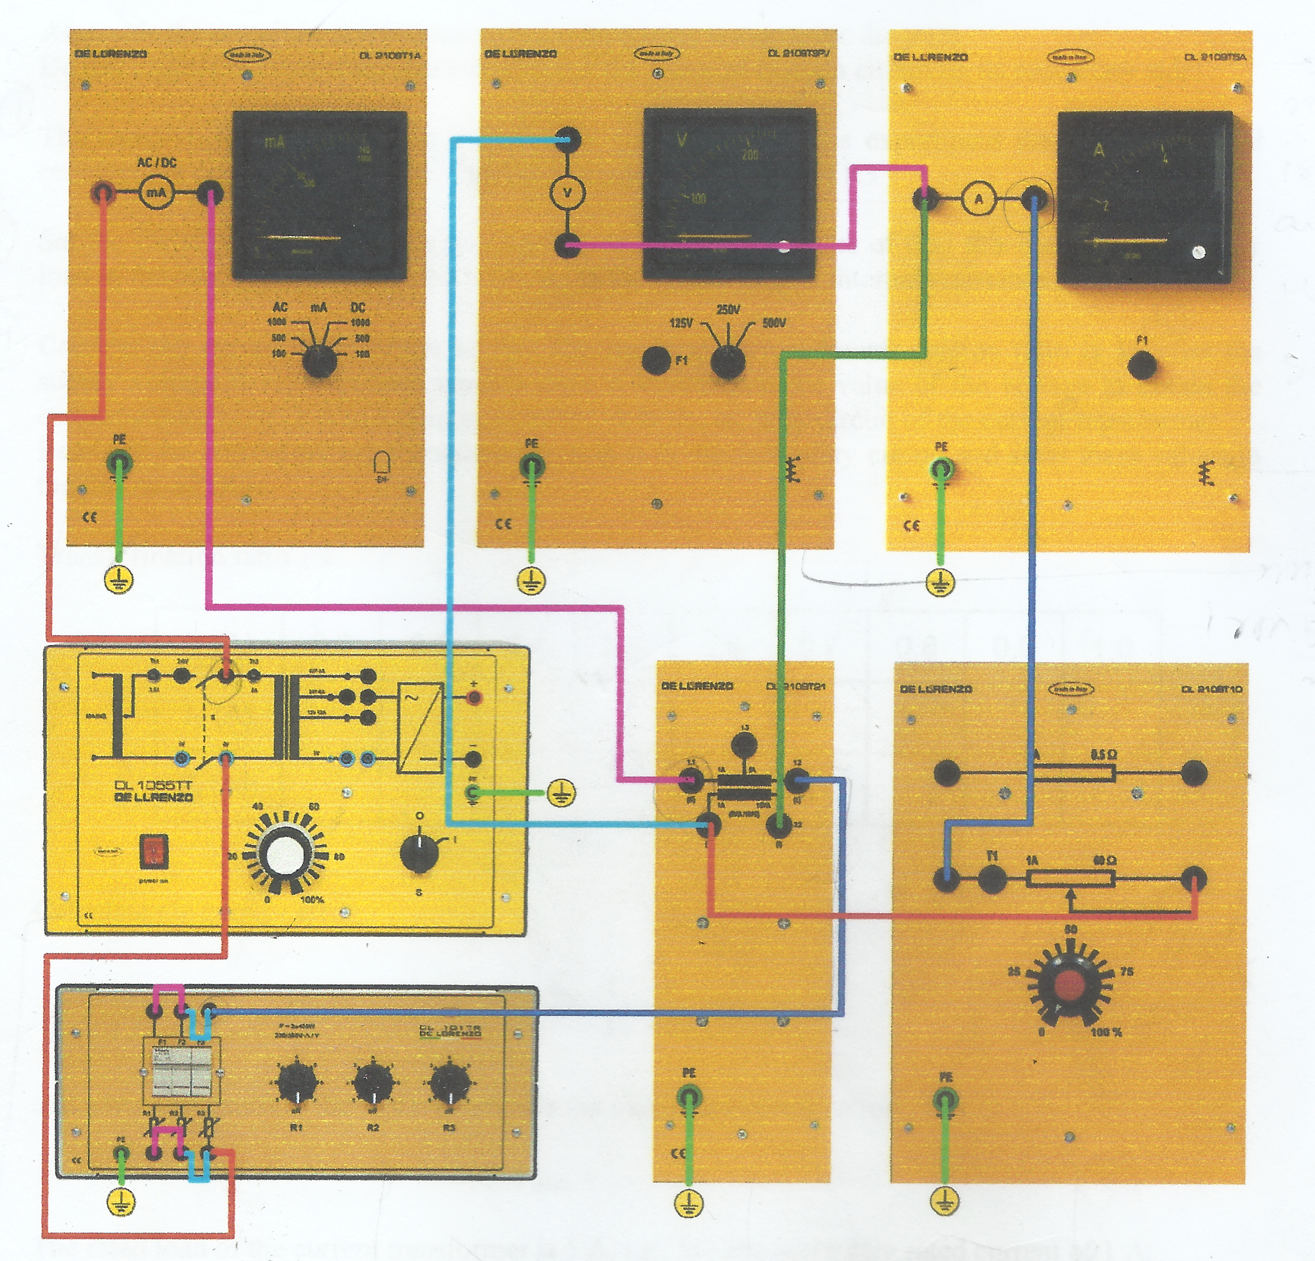

Figure 2 Current T/F circuit

**Procedure:**

* Connect circuit as shown in Fig 2.
* The resistive elements should be connected in parallel.
* Set resistive loads of CT on secondary side to an initial value of 0%.
* Connect current transformer so that resulting current ratio is 1:1
* Set power supply voltage 0÷250v and increase value of primary voltage so that current increases from 0A to 1A in step of 0.1A in primary of current transformer.
* Set Load Resistance to approximately at 3Ω and repeat same calculations and enter measurements in table**.**
* **Transformation ratio 1:1**
* **Without Load:**

**Table 1:**

|  |  |  |  |  |  |
| --- | --- | --- | --- | --- | --- |
| **I1(mA)** | **10mA** | **20mA** | **30mA** | **40mA** | **50mA** |
| **I2(mA)** | 9.9 | 19.9 | 30.5 | 40.5 | 49.5 |
| **Fi(%)** | 1 | 0.5 | 1.6 | 1.25 | 1 |

**Calculate current error**:

**Fi = (KN.I2-I1/I1)*100%**

**Max ratio error** = 1.6 **%**

**Assignment:** Set Load Resistance to approximately at 5Ω and repeat same calculations and enter measurements in table**.**

* **With Load:**

|  |  |  |  |  |  |
| --- | --- | --- | --- | --- | --- |
| **I1(mA)** | **10mA** | **20mA** | **30mA** | **40mA** | **50mA** |
| **I2(mA)** | 9.9 | 19.9 | 29.5 | 39.5 | 47.5 |
| **Fi(%)** | 1 | 0.5 | 1.6 | 1.25 | 5 |

**Calculate current error**:

**Fi = (KN.I2-I1/I1)*100%**

**Max ratio error** = 5 **%**

**Assignment:**

* Repeat same procedure for transformation ratio of 5:1 calculates error and secondary current in tabular form.
* Replace 1A ammeter on primary side with 5 A ammeter to avoid damage.
* Bring your assignment in next lab session. Late submission of assignments will not be accepted.

**Transformation ratio 5:1**

* **Without Load:**

**Table 2:**

|  |  |  |  |  |  |  |
| --- | --- | --- | --- | --- | --- | --- |
| **I1(mA)** | **10mA** | **20mA** | **30mA** | **40mA** | **50mA** |  |
| **I2(mA)** | 1.9 | 4.5 | 5.5 | 7.5 | 9.9 |  |
| **Fi(%)** | 5 | 12.5 | 8.3 | 6.25 | 1 |  |

**Calculate current error**:

**Fi = (KN.I2-I1/I1)*100%**

**Max ratio error** = 12.5 **%**

**Assignment:** Set Load Resistance to approximately at 5Ω and repeat same calculations and enter measurements in table**.**

* **With Load:**

|  |  |  |  |  |  |  |
| --- | --- | --- | --- | --- | --- | --- |
| **I1(mA)** | **10mA** | **20mA** | **30mA** | **40mA** | **50mA** |  |
| **I2(mA)** | 1.7 | 3.5 | 5.0 | 6.5 | 8.5 |  |
| **Fi(%)** | 15 | 12.5 | 16.6 | 18.75 | 15 |  |

**Calculate current error**:

**Fi = (KN.I2-I1/I1)*100%**

**Max ratio error** = 18.75 **%**

* **Transformation ratio 1:1:**
* **Without Load:**

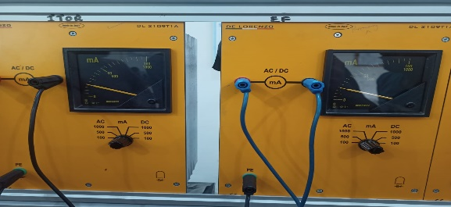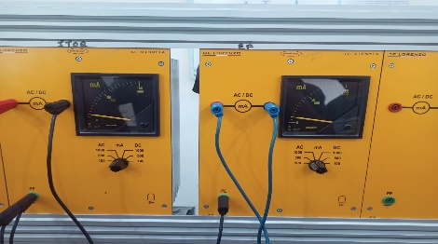

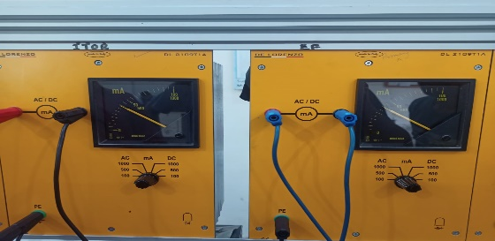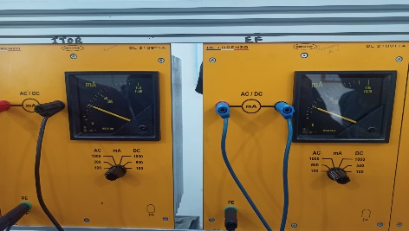

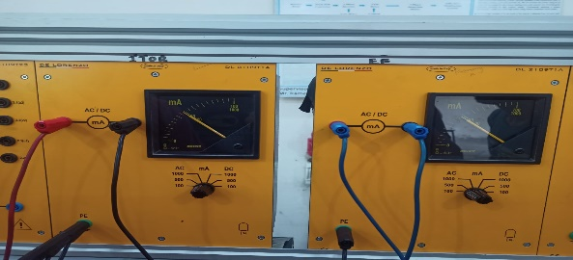

* **With Load:**

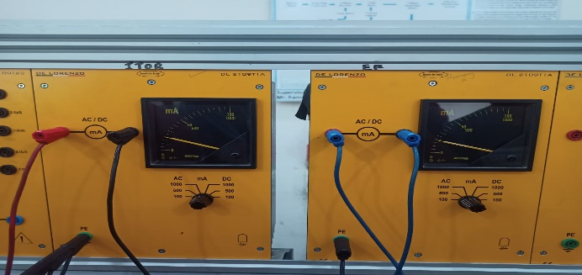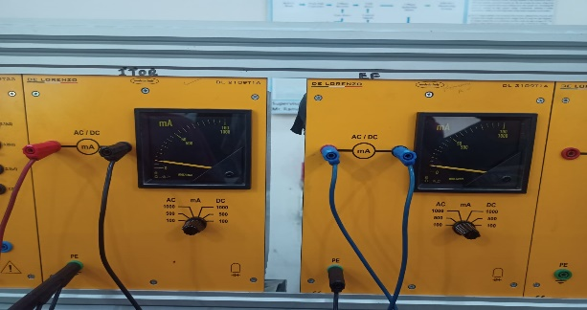

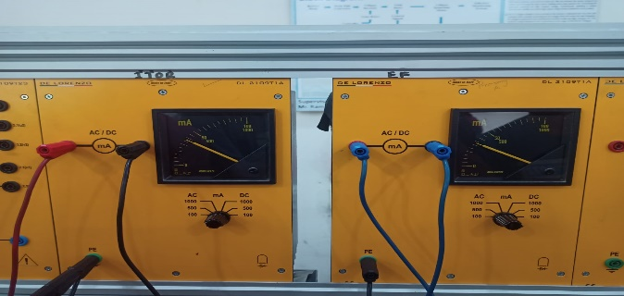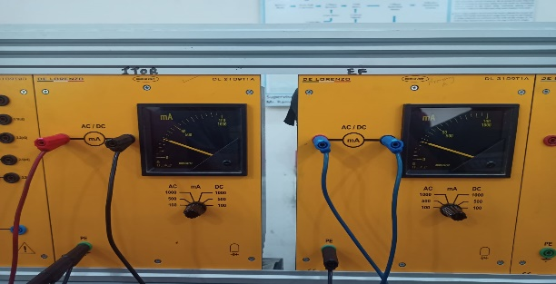

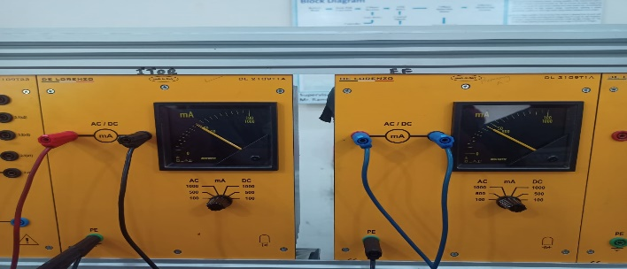

**Transformation ratio 5:1:**

* 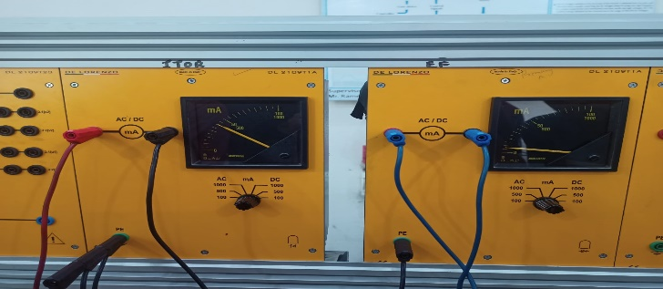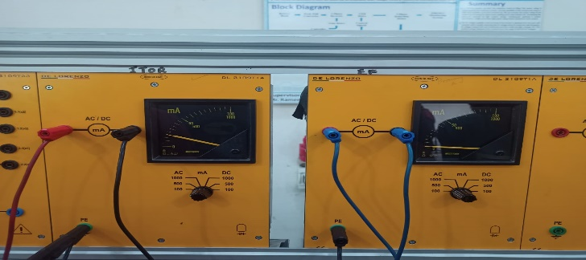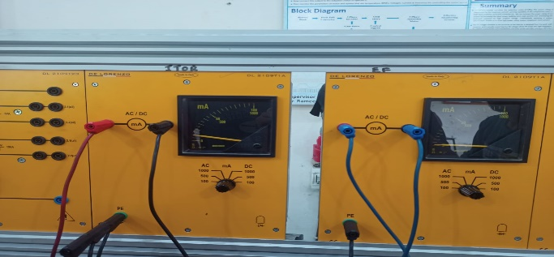**Without Load:**

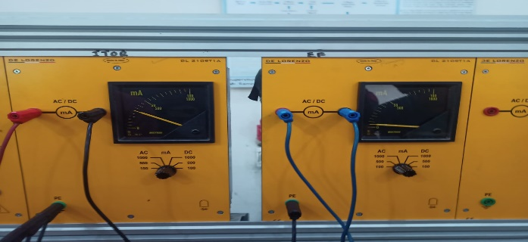

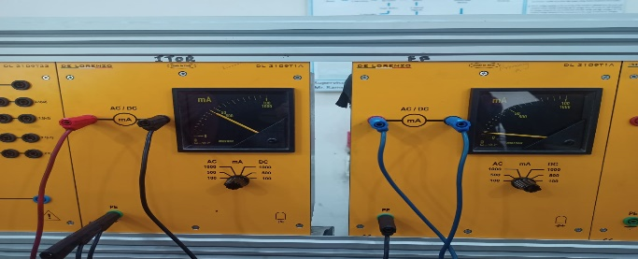

* **With Load:**

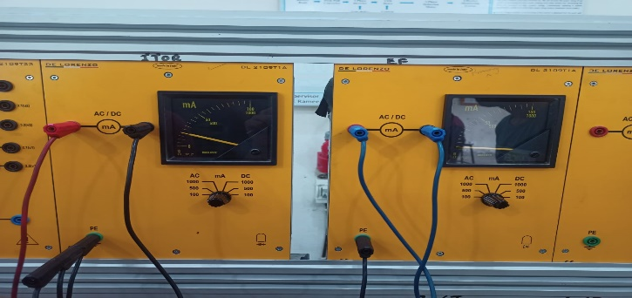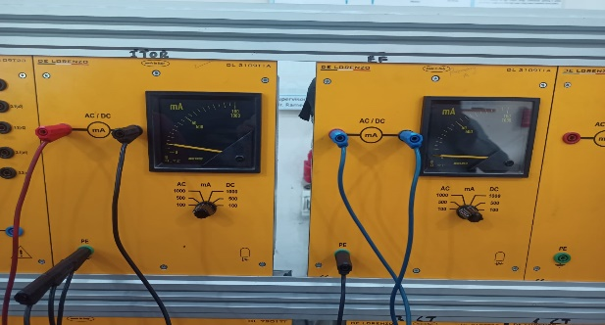

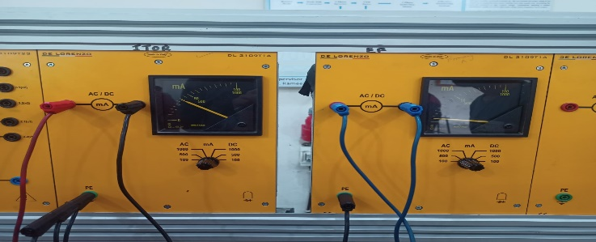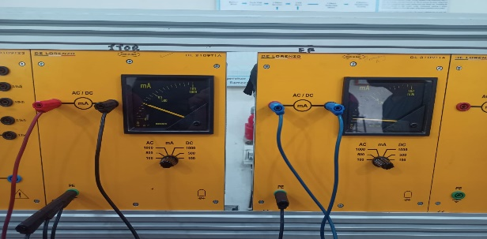

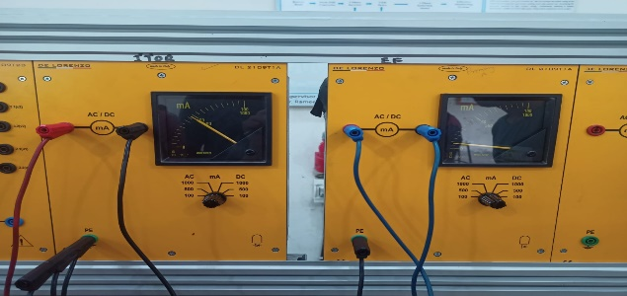

**Conclusion:**

In this lab we learn about Current transformer operation in substation by using De Lorenzo power system protection kit.

* In first case, we use 1:1 transformer without load and determine the secondary current and error. And then for same ratio of transformer we determine the error with applying variable load.
* In second case, we set transformer ratio to 5:1 and then observe the error and secondary current, with and without load.

We conclude that the error become small when transformer is of same primary and secondary turn ratio. And the error become increase with applying different primary to secondary turn ratio and variable load also.